Kinnoull and Paddockmuir

Land Management Plan Review

Initial Statutory and Public Consultation

October 2025

Key Features and Draft Objectives

The Kinnoull Hill and Deuchny Woods blocks serve as **recreation hubs** for the population of Perth and the surrounding area, we’ll maintain current facilities and continue to work with partnership organisations to improve or expand resources if possible.

The spread of **Phytophthora ramorum** disease is likely to start affecting the larch present in the LMP area in the near future. We’ll assess all areas of larch and ensure they are accessible if felling is required at short notice to slow the spread of the disease.

We’ll look after **Deuchny Hillfort**, a Scheduled Monument, by removing vegetation and reshaping the nearby woodland. We’ll also protect other historic features during forestry work.

Although **timber production** is a secondary focus in this area, we’ll continue to produce timber as part of good forest management. In particular, areas managed under low impact sylvicultural systems will require thinning operations to encourage a diverse next generation of trees to establish and patches of windblown trees will be recovered where possible.

We’ll confirm the locations of **private water supplies** and pipelines in the forest and nearby farmland and record them to make sure their catchments are well protected.

Some small **watercourses** start in the forest and flow into the River Tay. These rivers are important for wildlife and we’ll focus on improving riverbank habitats and keeping them connected.

We’ll also improve how the forest fits into the **landscape**. That means softening the forest edges and avoiding rigid, geometric shapes when replanting felled areas.

The entire LMP area is classed as **long-established woodland of plantation origin**. We’ll assess the area and manage it using the latest guidance.

Location and Landscape

Kinnoull Hill, Deuchny Woods, Binn Hill and Paddockmuir Wood sit to the east of Perth, looking out over the River Tay. Together they form one Land Management Plan called the Kinnoull Hill and Paddockmuir LMP.

These are well-established woodlands. Most are mixed conifers, with broadleaves more common on the Kinnoull Crags and at Paddockmuir. The larger woods have been managed for many years under a continuous cover system. You’ll also find open-grown Scots pine, older mixed conifers and newer spruce planting.

The bigger woods lie on steep slopes and crags that rise directly from the old river floodplain. The crags, and Binn Hill in particular, are very visible in the landscape. They help define the setting of Perth and the wider River Tay. Paddockmuir is smaller, lower and less prominent. It sits right by the Tay, around seven kilometres east of Deuchny Hill.

The plan area covers 260 hectares. Land ranges from five metres above sea level at Paddockmuir to 230 metres at the top of Deuchny Hill.

Kinnoull and Deuchny are part of the Kinnoull Hill Woodland Park, a 305-hectare site created in 1991. We manage this together with Perth and Kinross Council, who own the west-facing side of Kinnoull Hill. The park is very popular. It’s used daily by local residents and also attracts visitors from further afield.

Forestry and Land Scotland, then known as the Forestry Commission, bought Kinnoull, Deuchny and Binn Hill from the Kinfauns Estate in the 1930s. Perth and Kinross Council own the neighbouring western section of Kinnoull Hill, which was gifted to the people of Perth in 1924.

Since 1991, we and Perth and Kinross Council have worked together to care for and develop the Woodland Park.

Soils

Kinnoull, Deuchny and Binn Hill all sit on rocky hilltops formed from ancient volcanic activity. The crags of Kinnoull Hill show clear layers of old lava flows.

Most of the soils here are brown earths. On the south side they tend to be calcareous, while the north-facing slopes are more acidic. Some areas have shallow, dry soils, which can make trees more vulnerable during long dry spells.

Paddockmuir is very different. It lies on low, wet ground next to the River Tay, within the old floodplain.

Woodland Description

## Age Class

Most of these woods are now mature, with the majority of trees over 60 years old. There are very few young trees, as little planting has taken place in recent decades. About one tenth of the area is open or recently felled, which, when restocked, will gradually bring more young woodland back into the mix.

Figure 1: current age class coverage.

Table 1: current age profile.

| **Age Profile** | **Area (ha)** | **Area (%)** |
| --- | --- | --- |
| Establishment (0-10 years) | 6.8 | 2.6 |
| Thicket (11-20 years) | 0 | 0.0 |
| Pole Stage (21-30 years) | 2.8 | 1.1 |
| Mature High Forest (31-60 years) | 44.7 | 17.2 |
| Old High Forest (61+ years) | 178.9 | 68.8 |
| Open Ground/Felled Awaiting Restock | 26.8 | 10.3 |
| **Total** | **260** | **100** |

## Species Coverage

Scots pine is the most common tree here, covering 23% of the area. Sycamore is next at 17%, followed by Sitka spruce at 13%. Together, oak, birch and larch make up around a quarter of the woodland. Smaller amounts of beech, ash, Norway spruce and Douglas fir are also present, alongside mixed conifers and mixed broadleaves.

Broadleaves now make up almost 41% of the woodland, which means we’re meeting the UK Forest Standard (UKFS) targets for broadleaf cover. Designed open space currently only constitutes 8% of the forest area, under the 10% target set in the UKFS.

When we choose what to plant next, we’ll keep building diversity. Productive conifers will be planted where they suit the soils and objectives of the area they’re planted in, while native broadleaves will help improve habitats and amenity value, especially along watercourses, adjacent to heritage sites and in areas with high public use.

Figure 2: current species.

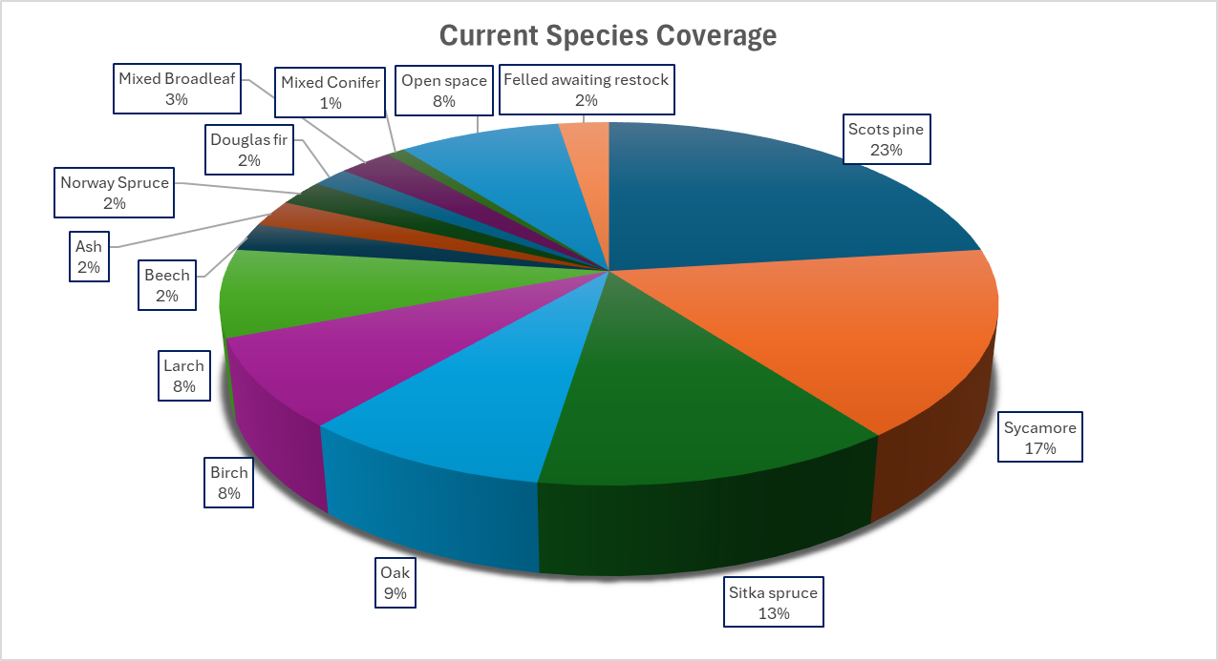

Table 2: current species.

| **Species** | **Area (Ha)** | **Area (%)** |
| --- | --- | --- |
| Scots pine | 59.8 | 23.0 |
| Sycamore | 43.3 | 16.7 |
| Sitka spruce | 33.1 | 12.7 |
| Oak | 22.9 | 8.8 |
| Birch | 20.6 | 7.9 |
| Larch | 20.4 | 7.8 |
| Beech | 6.4 | 2.5 |
| Ash | 6.3 | 2.4 |
| Norway Spruce | 6.1 | 2.3 |
| Douglas fir | 4.6 | 1.8 |
| Mixed Broadleaf | 6.8 | 2.6 |
| Mixed Conifer | 2.4 | 0.9 |
| Open space | 20.7 | 8.0 |
| Felled awaiting restock | 6.6 | 2.5 |
| **Total** | **260** | **100** |

Hydrology

Streams from all the woodlands flow into the River Tay, some directly south and others more slowly north. The River Tay Catchment Plan lists the Tay as a priority area under the Water Framework Directive. One of its main aims is to protect water quality, which is already rated as good or high

Public Access and Recreation

Kinnoull and Deuchny Woods are very popular for public access. Managing them for a wide range of users has become a high priority in recent years.

People come here to walk, run, cycle, ride horses and walk their dogs. There are also facilities for downhill mountain biking, and organised events for orienteering and other activities.

The Jubilee car park, owned by Forestry and Land Scotland, sits between Kinnoull and Deuchny. Perth and Kinross Council also provide a car park at Corsiehill. Many visitors come directly from Perth via Barn Hill and Kinnoull to the east. Riders and cyclists often use minor roads, farmland tracks and the Coronation Road.

The woods have a wide network of routes. These include marked and unmarked paths, several core paths and two public rights of way. The rights of way are the Coronation Road (east Deuchny) and a link from there to Perth, over Corsie Hill.

On Kinnoull Hill, we and the Council have upgraded the path network. This now includes a circular all-abilities trail. Visitors also enjoy events at the Shed and a small arboretum near the Jubilee car park.

Perth and Kinross Council provide dog waste bins in the park, but there are no formal toilets. Public engagement for the previous plan showed support for more access routes and path improvements.

Binn Hill is less visited, though it is still used by bikers and horse riders. At Paddockmuir, people can access the River Tay, which is also part of a core path route.

We’ll continue to support public access under the Scottish Outdoor Access Code.

Private Water Supplies and Associated Pipelines

We’re aware of some Private Water Supplies (PWS) in the surrounding area but will contact local residents to make sure we have a complete set of data to help with planning future forest operations.

PWS users are responsible for looking after their own supply. But where FLS manages the land, we also share the duty to protect water sources and supply networks like pipes, tanks and channels.

We’ll follow national water guidance. This means a 50-metre buffer around water sources, and a 20-metre buffer (10 metres each side) for pipelines. These buffers will be kept open, though we may include up to 20% native broadleaves.

If a water source is shallow or surface-fed, we’ll map the catchment, avoid using heavy machinery nearby, and manage brash heaps with care.

Historic Environment

The Iron Age fort on the top of Deuchny Hill is the only scheduled ancient monument in the plan area. It was mostly cleared during the previous plan period but is at risk from encroaching shrubs and regenerating trees, there are excellent views to the north and west from the summit.

Kinnoull and Binn towers were built in the 19th century on steep ground above the River Tay, inspired by castles on the Rhine. Kinnoull Tower is owned by Perth and Kinross Council, though it is surrounded by land managed by FLS. Binn Tower is privately owned but also lies within FLS woodland.

The Coronation Road, a public right of way, was once used by the Kings of Scotland traveling from Scone Palace to ferries across the River Tay.

Biodiversity

We’re supporting the Scottish Biodiversity Strategy by:

* helping forests regenerate naturally
* planting a wider mix of tree species
* improving woodland cover and understorey
* connecting forest habitats and other land uses

Our forests need to stay productive and continue storing carbon. But we’ll also design and manage them in ways that improve biodiversity and help wildlife move through the landscape.

We’ve recorded several Biodiversity List species and FLS Key Species across the plan area. These include:

* birds of prey
* bats
* red squirrels
* badger setts

The vast majority of the Kinnoull and Paddockmuir LMP area is designated as long-established woodland of plantation origin. These sites have been wooded since at least 1750 or 1860. We’ll assess their potential and manage them using the most up-to-date guidance.