Rosarie and Greenhills

Land Management Plan

2025 - 2035

LMP-14-2025

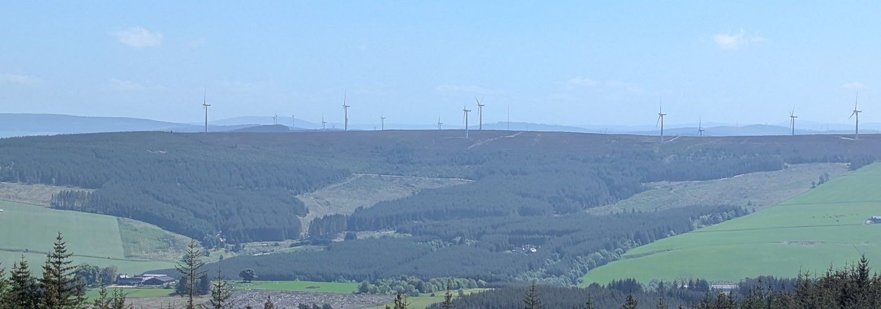

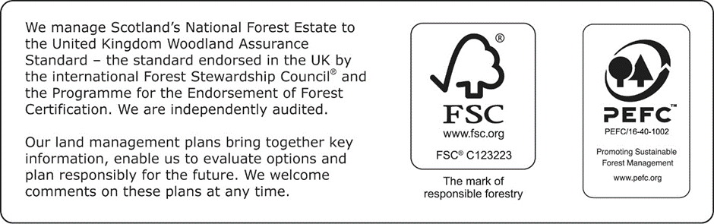

| Applicant’s details | |
| --- | --- |
| Applicant: | Forestry and Land Scotland |
| Address: | Huntly Office, Portsoy Road, Huntly AB54 4SJ |
| Agent’s name: | Euan Stewart |
| Agent’s position: | Forestry Consultant |
| Agent’s contact number: | 07581042793 |
| Agent’s email: | Euan.stewart2@forestryandland.gov.scot |

I hereby apply for a permission to fell the trees described in this application and I certify that:

* I have notified all stakeholders that may be affected by the felling in this application and sought their views prior to submitting this application;
* I am authorised to sign legal contracts on behalf of Forestry and Land Scotland;
* Any necessary consents from any other person(s) if required, have been obtained;
* I have made the necessary checks with the local planning authorities regarding Tree Preservation Orders and Conservation Areas;
* I hereby acknowledge that Scottish Ministers may process any of my personal data contained in or relating to this application in accordance with the terms of Scottish Forestry's Privacy Notice, a copy of which is available at www.forestry.gov.scot;
* Where applicable and appropriate I have submitted an EIA screening opinion form for operations contained within this application under the Forestry (Environmental Impact Assessment) (Scotland) Regulations 2017.
* I have read and understand this application fully and, to the best of my knowledge and belief, the information given in this application is complete, true, and accurate;
* I accept that any false or misleading information provided in this application constitutes an offence and may result in any felling permission based on this application being revoked at any time;
* I have read and understand Scottish Forestry’s Privacy Notice, a copy of which is available at https://forestry.gov.scot/privacy-complaints-freedom-of-information-and-requests-for-information.

|  |  |  |  |
| --- | --- | --- | --- |
| Signed,  Pp Regional Manager |  | Signed,  Pp Conservator |  |
| FLS Region |  | SF Conservancy |  |
| Date |  | Date of Approval |  |
|  |  | Date Approval Ends |  |
|  |  | Plan Ref. No. |  |

A. Description of Woodlands

A.1 Property Details

|  |  |
| --- | --- |
| Property (LMP) Name: | Rosarie and Greenhills |
| Grid Reference (main entrance): | NJ 3666 4993 |
| Nearest town or locality: | Keith |
| Local Authority: | Moray Council |

A.2 Location and Background

The Rosarie and Greenhills Land Management Plan (LMP) area is made up of four separate forest blocks located to the north and west of Hill of Towie, a few miles west of Keith in Moray. Together they cover approximately 1160 hectares (see **Map 1 - Location**).

The forest is situated in an area dominated by agriculture but with within a relatively dense cluster of forested areas covering much of the higher ground in eastern Moray. Hill of Towie, adjacent to the forest, is an open moor with a windfarm situated on the summit. The Spey valley is located roughly four miles to the west.

Parts of the LMP area have a long history of forestry and appear on first edition Ordnance Survey maps as being afforested. The rest of the forested area was largely established in the post war period of the 1950’s with two areas of new forest, Broadfield and Curlusk, established in 2017 and 2019 respectively.

A.3 Existing Schemes and Permissions

Type: Land Management Plan

Ref. No: LMP - 14

Details: The current Rosarie and Greenhills LMP was approved on 23/09/2015 and is due to expired on 23/09/2025.

A.4 Stakeholder Engagement

Please see **Appendix 1 – Consultation Record** for full details of consultation carried out during the LMP renewal, all issues raised by consultees, and how they have been addressed in the new LMP.

A.5 Long Term Vision and Management Objectives

Vision

The Rosarie and Greenhills forest blocks will continue to be a valuable source of sustainable timber for the local area. A diverse range of commercial conifer species will be established in resilient mixes where conditions allow, helping to mitigate the impacts of a changing climate.

In and around watercourses, along forest edges and near infrastructure, corridors of native broadleaves will have been established to safeguard these features, improve forest stability and improve environmental value. Tree species chosen for the restocks will match site conditions to ensure good growth as well as meeting the demands of species such as red squirrel.

All suitable areas will be continuously thinned to ensure crop stability, provide timber to local markets and to reduce the need for clearfell systems. The use of continuous cover systems will also benefit recreational use by reducing the intensity of forest management and retaining canopy cover.

Management Objectives

**Primary Objective 1:** **Continue to manage the forest as a sustainable timber resource.**

Indicator of objective being met: Areas suitable for commercial forestry will be harvested at a suitable age and restocked with species resilient to challenges caused by future climate change.

**Primary Objective 2: Protect and improve the water environment.**

Indicator of objective being met: Riparian zones around watercourses are identified in the LMP and suitable broadleaf species are prescribed for restocking. Any riparian areas felled within the upcoming plan period have open space buffers applied and native broadleaves established at restock.

**Primary Objective 3: Protect private water supply infrastructure in and around the forest**.

Indicator of objective being met: All reasonable efforts are taken to identify and map private water supplies in the area, with suitable buffers applied to all infrastructure and catchments identified for all surface fed supplies.

**Secondary Objective 1:** **Improve how the forest fits into the landscape.**

Indicator of objective being met: Where operations are taking place, efforts are made to soften the forest edges and avoid rigid, geometric shapes.

**Secondary Objective 2:** **Protect historic features within the forest.**

Indicator of objective being met: Ensure all heritage features are recorded and protected during forest operations.

A.6 General Site Description

A.6.1 Topography and Landscape

Rosarie and Greenhills, lies in upland Morayshire near Mulben and Keith. The land includes broad, rolling slopes rising from around 120 to 350 metres. The area is mostly rural with a low population.

This landscape is classed as Upland Farmland. It includes conifer plantations, open moorland and patches of native broadleaves. Some forest edges are highly visible from nearby public roads like the A95 and B9014 and from tourist rail routes, including from the summit of nearby Ben Aigen.

A.6.2 Geology and Soils

**Geology** - The solid geology underlying the site is composed mainly of quartzite on the hilltops with black graphitic schist lower down the slopes. These are overlain almost entirely with drift deposits of locally derived boulder till about 0.9 to 1.5m in depth thinning out towards hill tops. These tend to lead to the production of soils with medium to low nitrogen availability.

**Soils** – See **Map 8 - Soils** for a map showing the soil types present within the LMP area.

A.6.3 Climate

The Rosarie and Greenhills blocks are suitable for a range of commercial forestry species due to the relatively wide range of conditions between the higher summits and the valley bottoms. The current local climate is highlighted on the table below.

The north-east of Scotland is predicted to see a change in climate in the future which will impact forest management. According to the Forest Research Climate Matching tool, the accumulated temperature and the moisture deficit will both have increased slightly by 2050 matching most closely with the current climate of northern Germany and the Netherlands (Forest Research, 2024).

Furthermore, UK Climate Projections indicate the climate is expected to become more extreme with increased summer drought, winter flooding and storm events (UKCP, 2024).

|  |  |  |  |  |  |  |  |  |  |  |  |  |
| --- | --- | --- | --- | --- | --- | --- | --- | --- | --- | --- | --- | --- |
|  | **Accumulated Temperature [°C]** | | | | | | | | | | | |
| **Moisture Deficit [mm]** | 3000 2700 2400 2100 1800 1476 1200 976 776 575 | | | | | | | | | | | |
| 320  290  260  230  200  180  160  140  120  90  60  20 |  |  | very warm  moderately dry |  |  | warm  moderately dry |  |  |  | cool  moderately dry |  |
|  |  |  |  |  |  |  |  |  |  |  |
|  |  |  |  |  |  |  |  |  |  |  |
|  |  | very warm  slightly dry |  |  | warm  slightly dry |  |  |  | cool  slightly dry |  |
|  |  |  |  |  |  |  |  |  |  |  |
|  |  |  |  |  |  |  |  |  |  |  |
|  |  |  |  |  |  |  |  |  |  |  |
|  |  | very warm  moist |  |  | warm  moist |  |  |  | cool  moist |  |
|  |  |  |  |  |  |  |  |  |  |  |
|  |  |  |  |  |  |  |  |  |  |  |
|  |  | very warm  wet |  |  | warm  wet |  |  |  | cool  wet |  |
|  |  |  |  |  |  |  |  |  |  |  |
|  |  |  |  |  |  |  |  |  |  |  |

Figure 1: Local climate for Rosarie and Greenhills highlighted in red

A.6.4 Hydrology

Rosarie and Greenhills includes the sources of several small watercourses. Streams from Greenhills flow west to the River Spey. Others flow north and east to the River Isla and the River Deveron.

Below, these watercourses are listed with their current quality, quality objective and pressures. As can be seen in the table, forestry is not a current negative pressure on the watercourses.

The Burn of Aldernie and Mulben Burn (known as Canna Burn when it leaves the LMP area) have connectivity to the River Spey Special Area of Conservation (SAC) and Drinking Water Protected Area (DWPA) so forest operations may require enhanced mitigation measures when taking place within these catchments.

The River Isla catchment is also designated as a DWPA by Scottish Water.

Table 1: Watercourses and their current and future classification according to SEPA (SEPA, 2024)

|  |  |  |  |  |
| --- | --- | --- | --- | --- |
| ID | Name | Current  Classification | 2027 Objective | Pressure |
| 23181 | River Isla – Keith to Shiel Burn | Poor | Good | Alteration to beds/banks  Diffuse source pollution  Point source pollution |
| 23069 | Mulben Burn | Good | Good | Alteration to beds/banks |
| 23073 | Burn of Aldernie | Poor | Good | Alteration to beds/ banks |

A.6.5 Windthrow

The LMP area was heavily by Storm Arwen in November 2021, which caused significant damage; with subsequent storms exacerbating the windblow. As a result, approximately 65 hectares of windblow clearance operations have been carried out in the past four years.

The DAMS in the blocks is ranges between 17 (highly exposed) on the summits by Knockan and Hill of Towie and 10 (sheltered) in low lying areas adjacent to the A95. The majority of the forest area is classed moderately exposed to sheltered.

A.6.6 Adjacent Land Use

The LMP area is mostly surrounded by agricultural land, used for both grazing and arable farming. There is a large area of moorland associated with the Hill of Towie windfarm adjacent to the south as well as some areas of private forestry with short areas of shared boundary.

A.6.7 Access

The main access points into the forest blocks are via entrances on to the A95 and the connected C55H which are agreed routes for timber transport. There are historic access points at other points of the forest but many of these have become unusable over the years and are no longer functioning.

There is evidence of informal access being used historically from the areas of recent forest establishment at Broadfield but these have mostly been rendered defunct by a combination of windthrow, harvesting operations and unsympathetic restocking in the past.

There are no formal waymarked trails within the LMP boundaries although a formal path runs close to the northern entrance of the Greenhills block at the summit of Knockan.

The Isla Way also passes the forest adjacent to the native woodland establishment at Broadfield to the east.

A.6.8 Historic Environment

There are no scheduled monuments located within the plan area or in the immediate vicinity.

There several unscheduled features located throughout the LMP area, predominantly old field systems and cairns. These features can be seen mapped on Map 2 – Key Features.

A.6.9 Biodiversity

The Rosarie and Greenhills LMP area does not contain any designated conservation sites. Large areas of the blocks are however designated as LEPO sites (long-established plantation origin) in the ancient woodland inventory (AWI).

Red squirrels are regularly sighted within the blocks as well as several raptor species, badgers and their sets and wood ants. There are historical records of Capercaillie in the area, but the last known siting was in 2013.

A.6.10 Invasive Species

There are no issues with invasive species recorded within the LMP area.

A.7 Woodland Description

**Map 2 – Current species** shows the current tree species composition and pattern.

The area awaiting restock is due to several coupes being felled in the wake of Storm Arwen, only some of which have since been restocked.

Sitka spruce and Scots pine are the most common tree species, making up over half the forest. These main species are complimented by other productive conifer species such as Douglas Fir and Norway Spruce but in much smaller proportions. Due to the establishment carried out at Broadfield and Curlusk and several restocking operations focusing on broadleaves in the past 10 years, native broadleaved coverage is currently sitting at 15.8%.

Table 2: Area by species

| **LMP area by species** | | | | | | |
| --- | --- | --- | --- | --- | --- | --- |
| **Species** | **Current**  **Area (ha)** | **%** | **Year 10**  **Area (ha)** | **%** | **Year 20**  **Area (ha)** | **%** |
| Sitka Spruce | 486 | 41.9 | 478.5 | 41.2 | 467.5 | 40.3 |
| Scots Pine | 140.1 | 12.1 | 158.2 | 13.6 | 161.8 | 13.9 |
| Norway Spruce | 62.2 | 5.4 | 62.2 | 5.4 | 54.0 | 4.7 |
| Birch | 68.7 | 5.9 | 92.2 | 7.9 | 92.9 | 8.0 |
| Native Mixed Broadleaves | 52.2 | 4.5 | 57.0 | 4.9 | 58.8 | 5.1 |
| Larch | 36.1 | 3.1 | 24.7 | 2.1 | 20.7 | 1.8 |
| Oak | 41.7 | 3.6 | 41.7 | 3.6 | 41.7 | 3.6 |
| Aspen | 20.2 | 1.7 | 20.2 | 1.7 | 20.2 | 1.7 |
| Lodgepole Pine | 21.6 | 1.9 | 30.4 | 2.6 | 27.0 | 2.3 |
| Douglas Fir | 26.4 | 2.3 | 31.7 | 2.7 | 31.7 | 2.7 |
| Mixed Conifer | 0.7 | 0.1 | 1.3 | 0.1 | 7.9 | 0.7 |
| Felled awaiting restock | 51.55 | 4.4 | 0 | 0.0 | 0.0 | 0.0 |
| Open | 152.65 | 13.2 | 162.1 | 14 | 175.9 | 15.2 |
| **Total** | **1160.1** | **100** | **1160.1** | **100** | **1160.1** | **100** |

Chart 1: Species Coverage by Area

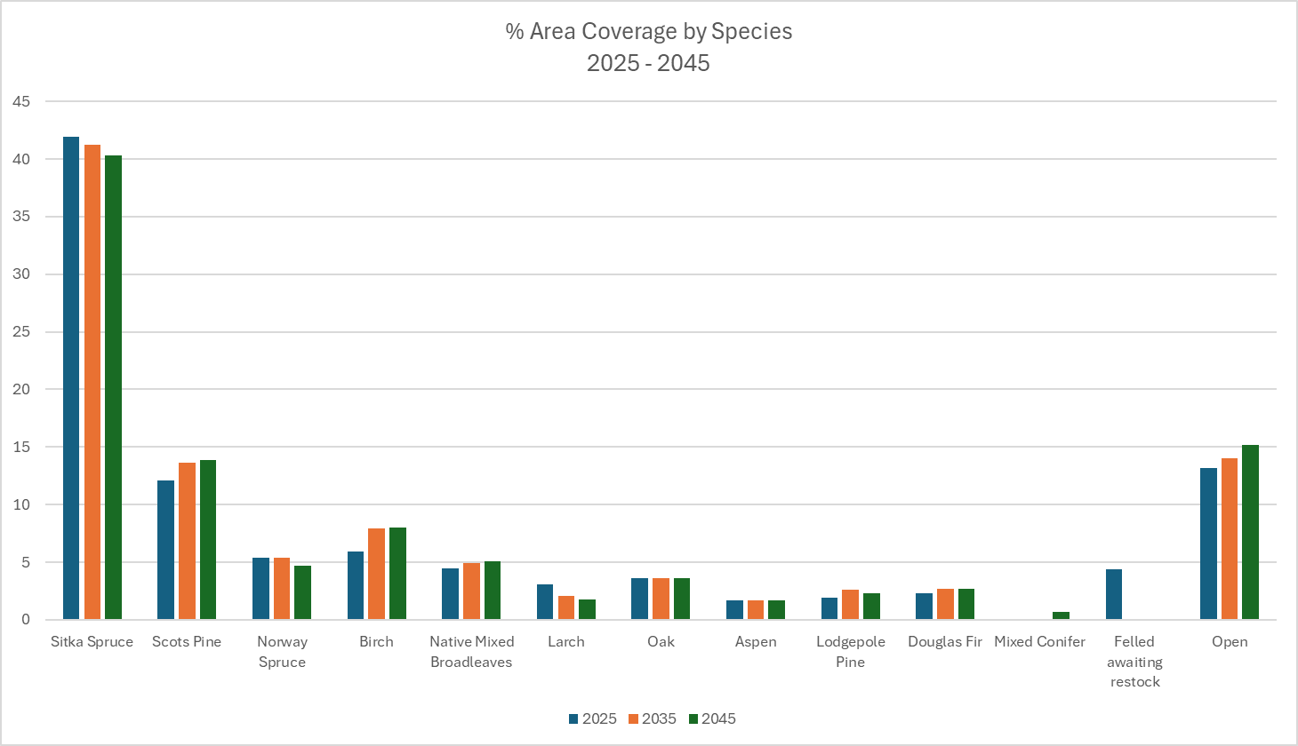

Table 3: Area by age

| **LMP area by Age** | | | | | | |
| --- | --- | --- | --- | --- | --- | --- |
| Age Class (years) | Current  Area (ha) | % | Year 10  Area (ha) | % | Year 20  Area (ha) | % |
| 0 – 10 | 378.6 | 32.6 | 160.5 | 13.8 | 87.8 | 7.6 |
| 11 – 20 | 57.7 | 5.0 | 343.5 | 29.6 | 160.4 | 13.8 |
| 21 – 40 | 234.3 | 20.2 | 232.2 | 20 | 399.7 | 34.5 |
| 41 – 60 | 83.9 | 7.2 | 103.0 | 8.9 | 230.9 | 19.9 |
| 61 - 80 | 160.8 | 13.9 | 8.9 | 0.8 | 33.0 | 2.8 |
| 81- 100 | 32.1 | 2.8 | 143.1 | 12.3 | 65.6 | 5.7 |
| 100+ | 8.5 | 0.7 | 6.7 | 0.6 | 6.8 | 0.6 |
| Not applicable | 204.2 | 16.6 | 162.1 | 14.0 | 175.9 | 15.2 |
| **Total** | **1160.1** | **100** | **1160.1** | **100** | **1160.1** | **100** |

Chart 2: Area by age

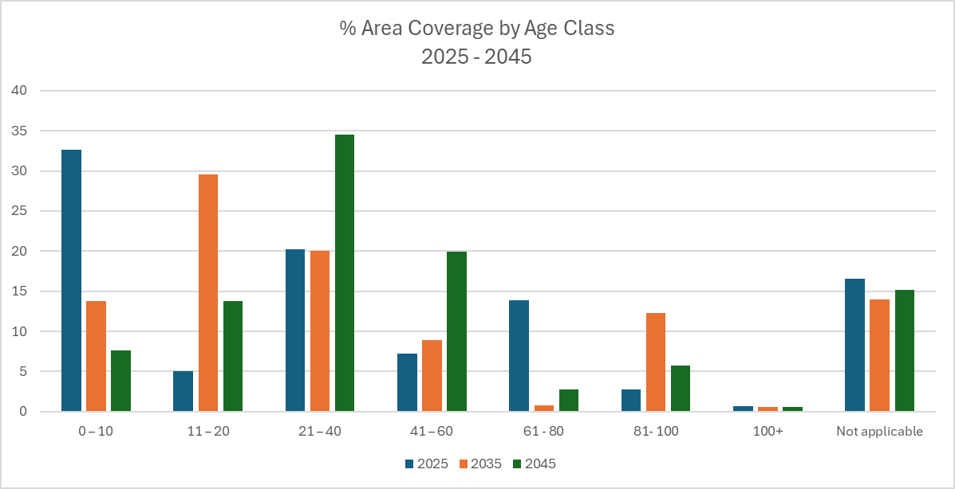

A.8 Plant Health

There are no major plant health issues within the Rosarie and Greenhills blocks. There are no records of recent statutory plant health notices (SPHNs) because of *Phytophthora ramorum*or *Dendodroctonus micans* in the area.

The LMP area sits within the Priority Action Zone (PAZ) for larch (Scottish Forestry, 2022) meaning SPHN’s require a swift follow-up. In the long-term it is however expected that larch can continue to be grown this far east.

Within the Forestry and Land Scotland Larch Strategy the blocks are found in the PAZ ‘less vulnerable zone’. In this zone pre-emptive felling will be the exception rather than the rule. There are no felling targets set or strategic access provision proposals for these areas.

Considering the history of woodland cover, the fertility and the pH level, butt rot, particularly *Heterobasidion annosum*, is likely to be an ongoing concern in the blocks. Forest management will need to be mindful of the risks of butt rot and limit spread through careful thinning and application of urea on cut stumps.

B. Analysis of Information

B.1 Constraints and Opportunities – and Concept

Table 4: Constraints and Opportunities by factor

|  |  |  |
| --- | --- | --- |
| **Constraints and Opportunities** | | |
| **Factor** | **Constraints** | **Opportunities** |
| Wind damage | There have been several areas felled as a result of Storm damage recently, resulting in a large area of fallow land. | Potential to delay felling of crops desirable for ecological reasons to offset additional felling. Restock creates opportunity for diversification of species. |
| Water Environment | Constraints around working near watercourses and private water supplies | Potential to improve species composition of riparian corridors and provide connectivity throughout the forest via restock. Suitable buffers around private water supply infrastructure can be added where it does not currently exist. |
| Caring for the Historic Environment | We will undertake suitable work practices on operational sites with known historic assets (and those discovered during operations). | We will ensure positive conservation management at significant historic assets, undertaking scrub control, condition monitoring and archaeological recording where necessary. |
| Landscape | Constraints on felling coupe size and phasing due to impact on local landscape. | Take opportunities to reduce impact on landscape through sympathetic felling and restock design. |

Concept

As mentioned, the LMP area has sustained significant damage during recent storms, the majority of which has been cleared and is being restocked. Where felling and/or restocking is still to take place, species choice is guided by long-term viability and productivity of the species, soil conditions, tree health issues, a changing climate and the presence of notable species such as red squirrel. Where mature crops can be retained this will be done for the benefit of environmental and recreational values.

The primary objective for this LMP is maintain Rosarie and Greenhills as a sustainable timber resource, but with the addition of the Broadfield and Curlusk establishment schemes, the plan area also acts as a valuable resource for biodiversity.

The main commercial zones of the LMP area will continue to be managed under clearfell management systems, with a focus on ensuring the sustainability of the forest going forward. Opportunities to transition some of the younger areas of the crop towards Low Impact Silvicultural Systems (LISS) will be taken where possible by ensuring thinning interventions are taken regularly and first thinnings in particular are programmed at a suitable time.

We will ensure that historic assets (both designated and un-designated) are included within our land management and operational plans and are managed in line with UK Forestry Standard.

When felling takes place near heritage features or utilities infrastructure, the restock will safeguard the infrastructure in the long-term through low density planting with the aim of moving this towards a minimum intervention management system. Similarly, felling along watercourses will facilitate the establishment of riparian zones which will improve environmental value and water quality.

Although it is unlikely that the areas of productive broadleaf planting at Broadfield will reach a height where thinning and timber extraction is possible during this plan period, the crop will be monitored and decisions taken on whether improvement operations such as pruning are necessary at this stage.

C. Management Proposals

C.1 Silvicultural Practice

Most of the LMP area will be managed for mixed purposes and will be restocked at productive densities with a majority conifer species. Considering the terrain and exposure all the forest is thinnable and access using harvester/forwarder combinations is possible throughout. Several coupes, which have not been thinned, are now past first thinning age, these will be clearfelled and restocked once they are most marketable.

Restocking will in general require ground preparation in the form of hinge or inverted mounding on the gleys and scarification on the podzols. Lower density planting of broadleaved species will be carried out along watercourses and to establish windfirm edges around the block and along key infrastructure. A focus of the restock is to divide the forest into windfirm, manageable units to reduce impacts of climate change and to establish the right species for continuous cover forestry.

C.2 Prescriptions

C.2.1 Felling

Sites proposed for clear felling in the plan period are identified as Phase 1 and Phase 2 management coupes on **Map 4 – Management Coupes**. **Table 6** sets out the scale of felling.

Table 6: Felling, Gross figures

| **Scale of Proposed Felling Areas** | | | | | | | | | | | | | | | | |
| --- | --- | --- | --- | --- | --- | --- | --- | --- | --- | --- | --- | --- | --- | --- | --- | --- |
| Total Plan Area |  | |  | 1160.1 | | ha | |  | |  | |  | |  |  |  |
| Felling | Phase 1 | % | | | Phase 2 | | % | | Phase 3 | | % | | Phase 4 | % | LTR  (including CCF) | % |
| Area (ha) | 46.43 | 4.0 | | | 53.58 | | 4.6 | | 60.3 | | 5.2 | | 27.02 | 2.3 | 189.31 | 16.3 |

Stands adjoining felled areas will be retained until the restocking of the first coupe has

reached a minimum height of two meters. Phase 1 and 2 clearfell coupes identified in this plan with known adjacency issues are listed below with the planned approach to achieving height separation. For any future clearfell coupes where adjacency is not possible, and there is no exemption under the Scottish Forestry Act, an amendment will be discussed and agreed with Scottish Forestry before the coupe is felled.

The only coupe with a potential adjacency issue is 14459 (see Map 5 – Management). The adjacent coupe to the south-east was felled after being damaged by Storm Arwen and is due to be restocked in the 25/26 planting season. Felling of coupe 14459 will be planned for late in phase 2 to ensure the surrounding crop will have grown to an average of two meters in height.

Considering the geomorphology, soils and access, all coupes are expected to be worked using harvester/forwarder combinations. An element of hand felling might be required for the felling of large edge trees or oddly shaped trees and/or near infrastructure.

Brash mats (or alternative measures) will be used to protect sensitive soils. There will be minimal soil disturbance and machine movement on sites with clayey soils to reduce the risk of compaction or damage to the soil structure. Felling residue will usually be left on site to allow nutrient recycling, with consideration for the practicalities of restocking.

**Other tree felling in exceptional circumstances**

FLS will normally seek to map and identify all planned tree felling in advance through the LMP process.

However, there are some circumstances requiring small scale tree felling where this may not be possible and where it may be impractical to apply for a separate felling permission due to the risks or impacts of delaying the felling.

Felling permission is therefore sought for the LMP approval period to cover the following circumstances:

* Individual trees, rows of trees or small groups of trees that are impacting on important infrastructure (as defined below*), either because they are now encroaching on or have been destabilised or made unsafe by wind, physical damage, or impeded drainage. *Infrastructure includes forest roads, footpaths, access (vehicle, cycle, horse walking) routes, buildings, utilities and services, and drains.
* The maximum volume of felling in exceptional circumstances over the plan area covered by this approval is 75 cubic metres per calendar year. A record of the volume felled in this way will be maintained and will be considered during the five-year Land Management Plan review.

[N.B. Trees may be felled without permission if they are of less than 10 cm diameter at breast height (1.3 m), pose immediate danger to persons or property, are completely dead or are part of Authorised Planning Permission works or wayleave agreements].

C.2.2 Thinning

Potential sites for thinning in the plan period are identified on **Map 6** **– Thinning Coupes** and **Map 6 – Thinning Approvals**. **Table 7** indicates the potential area.

Table 7: Thinning Areas

|  |  |
| --- | --- |
| **Thinning Areas** | |
| **Species** | **Thinning (ha)** |
| Sitka spruce | 263.5 |
| Scots pine | 125.5 |
| Birch | 38.9 |
| Norway spruce | 28.9 |
| Larch | 23.2 |
| Oak | 20.9 |
| Aspen | 20.1 |
| Mixed broadleaves | 18.6 |
| Douglas fir | 16.5 |
| Lodgepole pine | 15.6 |
| Alder | 12.1 |
| Mixed conifer | 0.5 |
| Total | 584.2 |

Wherever possible the region will continue to maximise the area managed through thinning. FLS policy assumes that all productive conifer crops will be thinned. The only exceptions are where:

* Thinning is likely to significantly increase the risk of windblow.
* A single thinning operation is likely to require an unacceptably large initial investment in relation to the potential benefits due to access or market considerations.
* Thinning is unlikely to improve poorly stocked or poor-quality crops.

There are several areas of young conifer plantation within the plan area which would benefit from thinning as soon as possible, therefore carrying out thinning activities throughout the area in phase 1 is a priority. The areas of broadleaves highlighted for thinning approval are unlikely to require full thinning operations within this plan period, but approvals have been sought to allow negative selection respacing operations to be carried out if necessary.

The thinning coupes within the plan area will be worked at a seven-year interval.

Thinning will normally be carried out at, or below, the level of marginal thinning intensity (i.e. removing no more than 70% of the maximum mean annual increment (MAI), or Yield Class (YC), per year). Higher intensities (no more than 140 % of maximum MAI, or YC, per year) may be applied where thinning has been delayed, larger tree sizes are being sought or as part of a LISS prescription. In all cases work plans will define the detailed thinning prescription before work is carried out and operations will be monitored by checking pre and post thinning basal areas for the key crop components.

C.2.3 Low Impact Silvicultural Systems (LISS)

Areas identified for LISS management are shown on **Map 4 – Management Coupes**.

At present, the only areas designated as LISS are areas of productive broadleaves at Broadfield. As mentioned above, the crops are still too immature to require a significant intervention within this plan period aside from the potential for some selective negative respacing.

Several other areas of conifer in the main blocks have the potential to be managed under LISS in the future and opportunities will be taken to increase the area managed under these systems once further thinning interventions have been carried out and the success of regeneration assessed.

C.2.4 Long Term Retentions (LTR) / Natural Reserves

Several Long-Term Retentions are found in the LMP area. (See **Map 4 – Management Coupes**). These consist mainly of broadleaf species planted with the main objective being to provide environmental benefits. There are also small areas of veteran Scots pine and patches of windblow to be retained for their biodiversity benefits.

No areas in Rosarie and Greenhills are designated as Natural Reserve.

C.2.5 Restocking Proposals

Planned restocking of felled areas, and proposals for the future habitats and tree species over the whole plan area are shown on **Map 5 – Future Habitats and Species**. See **Table 8** and **Appendix 4 – Restock Prescriptions** for areas, establishment, and mix proportions. Timing of restocking will comply with the plan tolerance table shown in **Appendix 2 – Tolerance Table.**

Table 8: Restocking

| **Felling phase** | **Coupe Number** | **SS** | **NS** | **SP** | **LP** | **DF** | **NMB** | **BI** | **MC\*** | **Open** | **Total (ha)** |
| --- | --- | --- | --- | --- | --- | --- | --- | --- | --- | --- | --- |
| Felled | 14285 |  |  |  |  |  | 0.75 |  |  | 0.75 | 1.5 |
| Felled | 14461 |  |  | 1.45 |  |  |  | 0.36 |  |  | 1.81 |
| Felled | 14215 |  |  |  |  |  | 0.97 | 3.39 | 0.48 |  | 4.84 |
| Felled | 14513 |  | 2.30 |  |  |  | 1.60 | 2.30 |  | 0.30 | 6.5 |
| Felled | 14554 | 11.90 |  | 8.10 | 11.90 |  |  | 5.0 |  |  | 36.9 |
| 1 | 14512 |  |  |  |  |  | 0.77 | 1.15 |  |  | 1.92 |
| 1 | 14605 | 18.05 | 10.59 | 5.45 |  |  |  | 1.36 |  | 0.32 | 35.77 |
| 1 | 14342 |  |  | 5.90 |  |  | 0.57 | 1.70 |  | 0.57 | 8.74 |
| 2 | 14140 | 2.31 | 3.92 |  |  | 5.30 | 0.07 |  | 0.07 | 1.46 | 13.13 |
| 2 | 14722 |  |  | 14.6 |  |  |  | 3.64 |  |  | 18.24 |
| 2 | 14459 |  |  | 17.6 |  |  | 0.21 | 4.4 |  |  | 22.21 |
| **Total (ha):** |  | **32.26** | **16.81** | **53.1** | **11.9** | **5.3** | **4.94** | **23.3** | **0.55** | **3.4** | **151.56** |

**\*** Expected to be achieved via regeneration

Stocking densities will be at least 2,500 stems per ha for conifers and 1,600 stems per ha for broadleaves unless stipulated otherwise in **Appendix 4 – Restock Prescriptions**. If the restock should fail to reach these levels the site will be beaten-up to the required planting density. This will be assessed at year 3 and year 5 after planting with beat-up by at least year 5.

Hot planting (i.e. 6-12 months post felling) will be the default position with other factors (Hylobius, weed growth, regeneration, resources etc.) accounted for in decision making to decide the most appropriate establishment window. Sites must be planted within 2 years of felling.

Native broadleaves of local origin such as birch, aspen, oak and willow will be preferred if available. If not available, then trees from an alternative origin will be used provided this origin makes them suitable to grow and thrive in the prevailing site conditions. Where Sitka spruce is to be used for restocking, we will endeavor to use improved SS transplants, provided the nursey is able to supply them in sufficient quantities. If appropriate sites present themselves, i.e. good soils, low risk of Hylobius attack and the potential of yield class 14 or higher crops, then VPSS will be used if available. Over and above this, only certified material will be used for species covered by the Forest Reproductive Material Regulations.

All areas identified for restocking by natural regeneration will be recorded and programmed for inspection in accordance with the East Region Policy on Restocking Felled Ground. This policy sets out that, for Natural Regeneration, the sites are to be under effective management by year 4 after felling. At this point it is necessary to have trees across the site at a suitable density with a reasonable expectation of establishment to 30cm within 2 years. Where this is unlikely to occur after monitoring at year 3-4, the site will be changed to restocking by planting. If there is a clear indication that regeneration is likely to reach the required densities but outwith the five year limit, permission will be sought from the regulator for an extension to the establishment period.

Enrichment planting might be used to ensure the target stocking densities of minimum 2500 stems per hectare for conifers and 1600 stems per hectare for amenity broadleaves are achieved if, on inspection, it is thought there is insufficient natural regeneration present to achieve restocking without intervention.

The choice of ground preparation for each site will be decided at the operational planning stage by the relevant establishment forester. Ground preparation techniques can vary greatly even across individual sites, so the most up to date advice will be applied at the time of the operation to ensure that soil structure and water quality is preserved whilst also providing an optimal environment for establishment depending on the species and site conditions. Forest and Water Guidelines, UK Forest Standard and UKWAS can all be used to help with the decision-making process if required.

Forest Research’s Field Guide to Soil Cultivation (Jens Haufe, 2019) and Scottish Forestry’s Cultivation for upland productive woodland creation sites will be referenced where necessary to help aid in the specific choice applied across any restock sites. The below table is a good indication of what ground preparation techniques will be applied, with the “Best Practice” option the target if possible. The majority of restock operations within the plan period take place on Podzols and Surface-water Gleys, best practice options for these soil types set out below:

* Podzols: Disk scarification or mulching if weed competition is high, no cultivation if site conditions suitable.
* Surface water gleys: Inverted mounding or no cultivation, depending on nutrient availability on individual sites.

Table 5: Soil types and preferred ground preparation methods

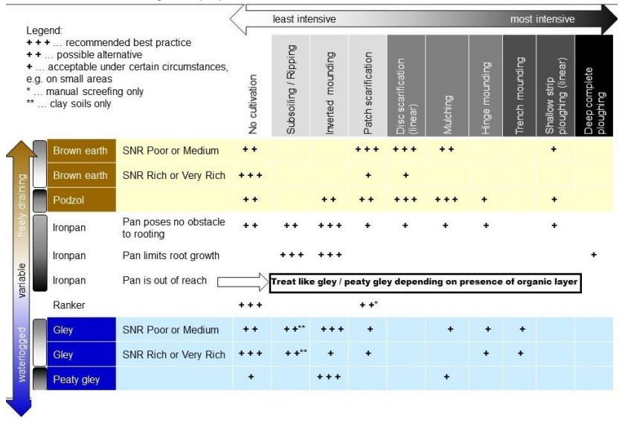

FLS is following a chemical reduction strategy. This involves the limiting of chemical application only to occasions when they are essential. To allow this strategy to be followed the Hylobius Management Support System will be applied and the minimum recommended fallow period used prior to restocking. This reduced fallow period will also reduce the potential need for herbicide applications to restocked areas.

C.2.6 Protection

Management of deer is an underpinning activity essential for the delivery of benefits from Scotland’s National Forest Estate. The aim is to manage healthy wild deer populations and manage deer impacts across the Estate consistent with the carrying capacity of the land and successful delivery of FLS land management objectives. Deer Management Plans direct the priorities for management and are available on request.

The deer population in Rosarie and Greenhills consists almost exclusively of roe deer because of the surrounding farmland. Browsing of young trees does take place but is currently not at a concerning level. Deer control will be carried out by FLS employees and/or contractor stalkers, and a mix of daytime and night-time stalking will be used.

Please see **Appendix 5** for a detailed Deer Management Plan for the LMP area.

C.2.7 Fence erection / removal

There are currently no plans for perimeter fencing the blocks. Small scale enclosures or tubes might be used to establish particularly palatable species. These protection measures will be of temporary nature and will be removed once the broadleaves have sufficiently established. The protection measures will be sited there were access, and construction is easiest and where the benefits of broadleaves are highest. FLS will regularly check protection measures to ensure they provide sufficient protection. Materials will be removed from site once no longer necessary and where possible recycled on other sites. If they cannot be recycled, they will be disposed of through appropriate waste channels.

There are currently a large number of tree tubes which are ready for removal on the eastern side of Broadfield, the area where tree tubes were used for establishment totals around 13.1ha. This area has been noted by the regional teams and programmed for tube removal and disposal at the earliest opportunity as per UKFS guidance.

C.2.8 Road Operations

**Map 7** **-Timber Haulage** shows the existing forest road network, timber haulage egress points, and any local ‘Agreed Timber Transport Routes’.

There is one additional spur road of 100m planned to aid extraction of coupe 14342, shown on Map 7.

Road upgrades will be carried out to facilitate forest operations if needed in the future. Material for road maintenance and upgrades will be bought in from local quarries. In case of a changes to the footprint of the road a detailed workplan will be created and **Appendix 2 – Tolerance table** and the EIA Scoping Opinion Request thresholds will be adhered to.

C.2.9 Public Access

Visitors are welcome to explore FLS land and will only be asked to avoid routes while certain work is going on that will create serious or less obvious hazards for a period (e.g. tree felling). Scotland’s outdoors provides great opportunities for open-air recreation and education, with great benefits for people’s enjoyment, and their health and well-being. The Land Reform (Scotland) Act 2003 and the Scottish Outdoor Access Code ensure everyone has statutory access rights to most of Scotland’s outdoors, if these rights are exercised responsibly, with respect for people’s privacy, safety and livelihoods, and for Scotland’s environment. Equally, land managers must manage their land and water responsibly in relation to access rights, and FLS will only restrict public access where it is necessary and will keep disruption to a minimum.

This plan area is not heavily used for recreation when compared to other FLS landholdings nearby but there is anecdotal evidence of historic public access, particularly within the Broadfield establishment scheme. Desire lines found within felling coupes will be protected during operations where this is operationally feasible.

Long term informal recreation will be managed by providing a diverse age and species structure throughout the forests. Recreational usage itself will ensure the maintenance and development of informal paths. Where operations result in a change of forest structure recreational use will adapt to the changed structure.

There are no Core Paths passing through afforested areas within the LMP boundaries but there are some which utilise public roads adjacent to the forest. Reference will be made to the Moray Council Core Path Plan when planning operations in these areas.

C.2.10 Historic Environment

Our Land Management Planning Process is informed by desk-based assessment, stakeholder consultation and professional archaeological walkover surveys where required.

Our key priorities for archaeology and the historic environment are to undertake conservation management, condition monitoring and archaeological recording at our significant historic assets; and to seek opportunities to work in partnership to help to deliver *Our Past, Our Future: the Historic Environment Strategy for Scotland* and *Scotland’s Archaeology Strategy*. Significant heritage features will be protected and managed following the *UK Forestry Standard 5th Edition* (2024) and *UKWAS* (2024).

Harvesting coupes, access roads and fence lines will be surveyed prior to any work being undertaken in order to ensure that upstanding heritage features can be marked out and avoided. At establishment and restocking, work prescriptions remove relevant heritage features from ground disturbing operations and replanting. Where appropriate, significant heritage features are recorded by archaeological measured survey, see active conservation management and may be presented to the public with interpretation panels and access paths. Opportunities to enhance the setting of important sites and landscapes will be considered on a case-by-case basis (such as the views to and from a significant designated historic asset).

The *Regional Historic Asset Management Plan* includes conservation management intentions for those designated historic assets in Scotland’s national forests. Details of all known heritage features are held within the *Forester Web Heritage Data* (built using national and regional historic environment records) and included within specific operational *Work Plans* to ensure damage is avoided. Designated historic assets, significant heritage features and relevant heritage features will be depicted on all relevant operational maps.

C.2.11 Biodiversity

UK Forestry Standard guidance is to manage a minimum of 15% of the forest management unit, the LMP area, with conservation and the enhancement of biodiversity as a major objective. The figure for this plan is currently 25%, rising to 28% over the LMP period.

There are several key species located within the plan area including: schedule one birds of prey, red squirrels, pine martens and badgers, all of which will be protected as per UKFS and NatureScot guidance.

The plan also helps to support the Scottish Biodiversity Strategy by:

* helping forests regenerate naturally
* planting a wider mix of tree species
* improving woodland cover and understorey
* connecting forest habitats and other land uses

Long-established woodlands of plantation origin (LEPO) and Plantations on Ancient Woodland Sites (PAWS)

As per **Map 2 – Key Features,** large areas of the LMP area are designated as LEPO.

As part of forming a more robust approach to our management of LEPO areas and to ensure they are being managed as per guidance in the relevant section of the UKFS, we will be carrying out several management steps as detailed below.

All areas designated as PAWS and LEPO will be assessed using the criteria in the table below to ensure that the current LMP proposals are appropriate and any additional LEPO areas that are known but not covered in existing databases will be added.

Table 9: Assessment criteria LEPO

| Ecological Potential | Old plantation features only | Old semi-natural features included |
| --- | --- | --- |
| High |  | A few remarkable ancient/veteran trees/notable woodland flora and/or frequent c. 150-year-old native trees and other old woodland remnants (e.g. abundant woodland specialist flora) within the plantation. And/or, in a substantial native woodland network |
| Medium | Frequent c. 150-year-old non-native trees embedded within younger plantation | Occasional c. 150-year-old native trees, occasional patches of woodland specialist flora and / or in a fragmented native woodland network. 1 |
| Low | Rare or occasional c. 150-year-old non-native trees embedded within younger plantation 2 | No obvious signs of old semi-natural woodland and isolated from a native woodland habitat network 1, 2 |

1. For Medium and Low Ecological Potential sites with native/semi-natural features, there could be old plantation features as well.
2. Those LEPO that were in the HCV sub-set and have been added to the PAWS layer, can be managed conventionally if they have Low Ecological Potential. If there are rare or occasional c.

After assessment, the future management is decided based on the following advice from FLS’ Native Woodland Ecologist:

“There is no imperative to convert to native species if the LEPO is currently dominated by non-natives. As with PAWS restoration, there is a strong preference for LISS management to maintain woodland conditions – avoiding huge changes to light levels, loss of humidity and increase in the water table – all consequences of clear-felling. The guiding principle should be to undertake sustainable management that will protect features of interest in the long-term.

As with PAWS restoration, sites with High Ecological Potential and Critical threats are the priority for management. LEPO with High Ecological potential will include features normally associated with ancient woodland sites and an increase in native species over time will normally be appropriate to embed veteran native trees and other flora in a wider native woodland matrix. This will be best achieved by favouring interesting features in repeated thinning operations.

The Ecological Potential of LEPO with frequent non-native veteran trees and no other features of biological interest will be Medium, therefore management of these sites should not take precedence over the highest value LEPO and true PAWS with frequent semi-natural veteran trees/rare native woodland flora.”

For this plan, a general assessment has been made by the regional environment teams and planning staff to ensure the LMP proposals are appropriate.

Within the Rosarie and Greenhills plan area, there are some small areas of high value LEPO which have been identified, mainly consisting of 100+ year old larch. These areas have been designated as long-term retention, and the intrusion of Sitka spruce regeneration is programmed to be removed periodically; typically when the wider area is being thinned.

Any areas of high or medium ecological potential will be assessed as part of the pre-felling checks carried out by FLS staff and any opportunities for retentions of high ecological value trees, habitats or deadwood reserves will be identified and built into the work planning process for any upcoming operations.

Restock species with LEPO designated areas in Rosarie and Greenhills have mostly been chosen with a long rotation in mind and are planned to be managed under LISS systems in the future. The exception being where the coupe has been assessed as being of low ecological potential and the restock prescription is for standard rotation commercial conifer planting.

Deadwood

Deadwood will be managed in accordance with the FCS Practice Guide: Managing Deadwood in forests and woodlands (Humphrey and Bailet, 2012) and supplemented by the FLS Guidance note: Deadwood Management – Summary Guidance for FLS Staff (Kortland, 2021).

Key principles applied:

* Retain and create as much deadwood as possible and create new deadwood on a continuing basis.
* Retain and create as many kinds of deadwood as possible.
* Favour native tree species when creating and retaining deadwood.
* Favour the retention and creation of large-diameter deadwood.
* Retain and create high stumps and snags (standing deadwood) within woodland and permanent open areas (but not on clear fells that will be restocked).
* Design the distribution of deadwood to maximise connectivity at the woodland management unit and coupe scale, ensuring they are not in obtrusive locations within the landscape.

**Map 10 – Deadwood Ecological Potential** shows the ecological deadwood potential of Rosarie and Greenhills, based on the following criteria:

Table 10: Description of Deadwood Ecological Potential classes

|  |  |
| --- | --- |
| **Deadwood Ecological Potential (DEP) class** | **FES woodland management categories included in this DEP class** |
| High | Natural reserves, ancient semi-natural woodlands, native pinewoods, riparian buffers along watercourses, PAWS with high ecological potential, wood pasture. |
| Medium | Minimum intervention areas of broadleaved woodlands, PAWS, LEPOs, long-term retentions, LISS coupes. |
| Low | All other stands (i.e. stands where timber production is the priority). |

Table 11: Description of management prescriptions for each DEP class

| **(DEP) class** | **Deadwood Management Prescription** |
| --- | --- |
| High | 1. Retain all existing veteran trees and deadwood apart from that which is a health and safety risk or where it would be highly obtrusive in the landscape 2. Retain all wind blow apart from that which is a health and safety risk 3. Deadwood distributed throughout the coupe 4. Seek opportunities to create particularly valuable deadwood e.g. import some large-diameter logs from nearby coupes when they are thinned or clear felled. |
| Medium | 1. Retain all existing veteran trees and deadwood apart from that which is a health and safety risk 2. Only harvest windblow of significant value or which poses a health and safety risk 3. Seek opportunities to create particularly valuable new deadwood e, g when felling big trees, retain some large diameter logs at the edge of the coupe 4. Where windblow is harvested, retain some blown trees in a group as ‘future deadwood’ where not obtrusive in the landscape |
| Low | NA |

C.2.12 Tree Health

There are few specific concerns around tree health in Rosarie and Greenhills.

Therefore, tree health will largely be managed through improving species and age diversification, continued thinning and ensuring appropriate species selection taking soils and climate change into account. As set out in **C.1** tree species will be carefully matched to soil type, this ensures resilience and reduces the opportunities for pathogens.

As noted in **A.8** there is a presence of butt and root rot fungi. To minimise the impact of these pathogens, forest management, including civils operations, will take care to minimise damage to stems and roots during operations. Furthermore, urea will be sprayed on stumps during felling or thinning operations to inhibit colonisation by *Heterobasidion annosum*.

C.2.13 Invasive Species  
There are currently no invasive non-native species (INNS) issues reported within the plan area.

However, monitoring will continue to be carried out and in case of colonisation by an invasive species, removal/treatment will take place. Where the presence of INNS crosses into neighbouring properties contact with neighbours will be sought to jointly remove INNS where possible.

C.2.14 New Planting

Not applicable.

C.2.15 Other

Wildfire

FLS continues to work closely with Scottish Fire and Rescue Service (SFRS) to prevent and tackle wildfires that threaten Scotland’s National Forests and Land. FLS support SFRS in their lead role for fire prevention and suppression through creating annual fire plans, maintaining a duty rota, and providing additional logistical support. FLS’s primary objective is always to protect people’s health, safety and wellbeing.

Private water supplies

As part of the design process for this LMP, a concerted effort has been made to identify any private water supply sources either within the plan area or within approximately 2km of the boundaries.

This was done by setting up an indicative “private water supply screening zone” around the LMP blocks and within this area checking against all relevant water supply data currently available including:

* FLS local private water supplies data
* Data provided by the local authority
* Drinking Water Protected Area data provided by SEPA
* Using a database of addresses to identify all residents of rural properties within 2km which are not located near a water main

There are private water supplies located in the vicinity of the plan area and some infrastructure such as pipes and storage tanks located within the block boundaries. Although none of the supplies registered are likely to be impacted by forest operations in this plan period, suitable buffers have been applied to the future restock species plan and catchment maps have been created for all PWS which have the potential to be affected by operations in the future.

Drinking Water Protected Areas (DWPA)

Scottish Water have provided detailed guidance on regulatory requirements and also a list of specific precautions for drinking water protection during forestry activities. These will be followed closely when planning and delivering any operations within a DWPA.

In addition, Scottish Water will be directly consulted within 3 months of any operations taking place.

Hydrology

Where operations along the main watercourses take place opportunities will be sought to naturalize watercourses by removing non-native species from the banks and re-establishing with open grown riparian woodland.

Surface water drains will not discharge directly into the water environment. East Region staff will remediate legacy drains of this type to avoid siltation problems during and after forestry operations by using tree roots and other natural methods to install anti siltation devices during harvesting operations and addressing the drains permanently during subsequent ground preparation operations. When natural means are not available plastic dams or semi-permeable netting might be used temporarily. When operations are finished this will be removed and reused.

Where opportunities exist to deliver environmental improvement by the alteration or removal of inappropriately designed or redundant structures - for instance upgrading of a culvert to allow fish passage or removal of a redundant weir - this will be undertaken in consultation with the relevant stakeholders, and we will register the operation on the SEPA website. Opportunities for morphological and ecological improvements may also be considered.

Where specific operations produce waste material not detailed above, East Region staff will liaise directly with SEPA to establish the level of permission/licensing required on a site-by-site basis.

C.3 Environmental Impact Assessment (EIA) and Permitted Development Notifications

|  |  |  |  |  |  |
| --- | --- | --- | --- | --- | --- |
| **Total area (hectares) for each project type and details by sensitive or non-sensitive area.** | | | | | |
| **Type of Project** | **Sensitive Area** | | **Non-sensitive Area** | | **Total** |
| Afforestation | %Con | %BL | %Con | %BL | ha |
| Deforestation | %Con | %BL | %Con | %BL | ha |
| Forest Roads | ha | | 0.2ha | | 0.2ha |
| Quarries | ha | | ha | | ha |
| Provide further details on your project if required. | | | | | |
| Planned spur road falls below threshold for EIA scoping or planning permission. | | | | | |

C.4 Tolerance Table

See **Appendix 2.**

Appendices

Map 1 – Location

Map 2 – Key Features

Map 3 – Current Species

Map 4 – Management Coupes

Map 5 – Future Habitats and Species

Map 6 – Thinning Coupes

Map 7 – Thinning Approvals

Map 8 – Soils

Map 9 – Timber Haulage

Map 10 – Deadwood Ecological Potential

Appendix 1 – Consultation record

Appendix 2 – Tolerance Table

Appendix 3 – Visualisations

Appendix 4 – Restock Prescriptions

Appendix 5 – Deer Management Plan